**­**

**Total Marks: 04**

**Marks Obtained:**

**Principle Management**

**Assignment 04**

**Submitted To: Dr. Beenish Ambereen**

**Date of Submission: 23-May-2024**

|  |  |  |
| --- | --- | --- |
| **S.NO** | **Student Name** | **Reg.no** |
| **01** | **Muhammad Salman** | **2212400** |
| **02** | **Mushahid Hussain** | **2212408** |
| **03** | **Ubaid-Bin-Waris** | **2212416** |
| **04** | **Muhammad Rayyan Amir** | **2212406** |
| **05** | **Jehanzeb Khalid** | **2212391** |

Table of Contents

**Front page01**

**Table of content02**

**Fauji Fertilizer company (FFC)03**

**Introduction to Fauji Fertilizer company (FFC)03**

**Key components of Monitoring and controlling system at FFC03**

Performance Metrics and key performance indicators (KPIs)03

Data collection and Analysis tools03

Regular performance review04

Feedback Mechanism04

**Impact on organization performance04**

Enhanced Decision making04

Improved operational efficiency04

Increased Accountability05

Enhanced Costumer sanctification05

Strategic Alignment05

**Result05**

**Conclusion06**

**Work Division06**

**References07**

**Plagiarism Report08**

**Role of Monitoring and Control Systems in Enhancing Organizational Performance**

**Fauji Fertilizer Company (FFC)**

Monitoring and control systems are essential tools for enhancing organizational performance. These systems provide mechanisms for tracking progress, ensuring strategic alignment, and facilitating timely interventions. This assignment explores the role of such systems within Fauji Fertilizer Company (FFC), a leading fertilizer manufacturer in Pakistan. The analysis will focus on how monitoring and control systems contribute to performance improvement within this context.

**Introduction to Fauji Fertilizer Company (FFC)**

Fauji Fertilizer Company is a prominent player in Pakistan’s agricultural sector, producing high quality fertilizers to enhance crop productivity. Established in 1978, FFC has grown significantly, driven by its commitment to innovation, quality, and sustainability. In a competitive and regulated industry, effective monitoring and control systems are crucial for maintaining operational efficiency and market leadership.

**Key Components of Monitoring and Control Systems at FFC**

* **Performance Metrics and Key Performance Indicators (KPIs)**
  + FFC employs a comprehensive set of KPIs to measure various aspects of its operations. These include production efficiency, product quality, environmental compliance, and financial performance.
  + **Examples** of KPIs at FFC include production yield, energy consumption per ton of fertilizer produced, waste reduction, customer satisfaction scores, and return on investment.
* **Data Collection and Analysis Tools**
  + Advanced data collection and analysis tools are integral to FFC’s monitoring systems. These tools gather real-time data from production lines, supply chains, and market activities, enabling detailed analysis.
  + FFC uses **Enterprise Resource Planning (ERP**) systems and specialized software for data analytics to monitor operations and identify areas for improvement.
* **Regular Performance Reviews**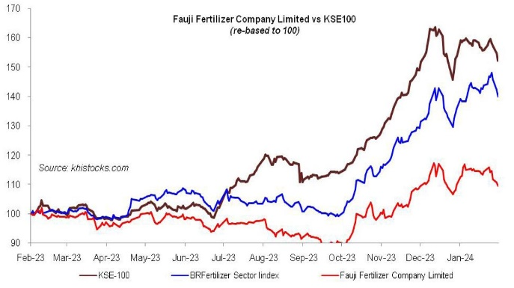
  + FFC conducts regular performance reviews at various organizational levels. These reviews involve assessing current performance against set targets and identifying improvement opportunities.
  + Monthly and quarterly performance review meetings are held to discuss progress, address challenges, and update strategies as needed.

Figure 1.1(Recent Performance (2023) Growth of 48.25 %)

* **Feedback Mechanisms**
  + Effective feedback mechanisms are essential for continuous improvement. FFC collects feedback from employees, customers, and other stakeholders to refine processes and enhance performance.
  + Customer feedback is gathered through surveys and direct interactions, while employee feedback is collected via performance appraisals and suggestion programs.

**Impact on Organizational Performance**

* **Enhanced Decision Making**
  + Monitoring and control systems provide accurate and timely information, enhancing decision making processes. Managers at FFC use performance data to make informed decisions regarding resource allocation, process optimization, and strategic initiatives.
  + For **example**, data on energy consumption helps in making decisions about upgrading equipment to more energy efficient models.
* **Improved Operational Efficiency**
  + By identifying inefficiencies and bottlenecks, monitoring systems enable FFC to streamline operations. Continuous monitoring of production processes helps in minimizing downtime and optimizing resource use.
  + The implementation of an automated monitoring system on production lines has resulted in a significant reduction in production delays and wastage.
* **Increased Accountability**
  + Establishing clear performance metrics and regular reviews fosters a culture of accountability. Employees at FFC are aware of their performance targets and are motivated to achieve them, knowing that their progress is monitored and evaluated.
  + Performance based incentives linked to KPIs encourage employees to consistently meet and exceed their targets.
* **Enhanced Customer Satisfaction**
  + Monitoring customer feedback and satisfaction levels allows FFC to address issues promptly and improve product quality and service. This proactive approach has led to higher customer retention rates and increased brand loyalty.
  + Initiatives such as ensuring timely delivery and maintaining product quality have been direct results of customer feedback analysis.
* **Strategic Alignment**
  + Continuous monitoring ensures that FFC remains aligned with its strategic objectives. Performance data is used to ensure all departments are working towards common goals, facilitating coordinated efforts and strategic coherence.
  + Strategic projects, such as expanding into new markets or launching new products, are guided by insights gained from monitoring systems.

**Results**

**Increased Efficiency**: The integrated system provided real-time insights into production metrics, enabling quick identification and resolution of inefficiencies. This led to a 15% increase in production efficiency.

**Reduced Environmental Impact**: Continuous monitoring of emissions and waste allowed FFC to implement more effective environmental controls, reducing waste output by 10%.

**Cost Savings**: Predictive maintenance capabilities reduced equipment downtime and maintenance costs, contributing to significant cost savings.

**Conclusion**

Monitoring and control systems are vital for enhancing organizational performance at Fauji Fertilizer Company. These systems have proven instrumental in improving decision making, operational efficiency, accountability, customer satisfaction, and strategic alignment. By leveraging advanced data analytics, regular performance reviews, and robust feedback mechanisms, FFC has maintained its competitive edge and achieved continuous improvement in a dynamic and regulated industry. This case study underscores the importance of effective monitoring and control systems in driving organizational success and sustainability.

**Work division**

1. **Muhammad Salman: Mission Statement Development**

Role: Gather input from stakeholders and craft a succinct mission statement.

1. **Mushaid Hussain: Objective Setting**

Role: Formulate clear, measurable, and timebound objectives aligned with the mission.

1. **UBAID BIN WARIS: External Environment Analysis**

Role: Analyze external factors using tools like PESTEL analysis and Porter's Five

Forces.

1. **Muhammad Rayyan Amir: Strategy Formulation**

Role: Develop strategies leveraging internal strengths and external opportunities.

1. **Jehanzeb Khalid: Conclusion and Summary**

Role: Summarize the strategic management plan and emphasize the importance of

continuous monitoring and adaptation.

**References**

**[1]. https://www.brecorder.com/news/40287533**

**[2].** [**https://en.wikipedia.org/wiki/Fauji_Fertilizer_Company**](https://en.wikipedia.org/wiki/Fauji_Fertilizer_Company)

**[3].**  **https://www.icap.org.pk/safaconference/sponsors/ffc.php**

**[4].** [**https://ffc.com.pk/company-profile/**](https://ffc.com.pk/company-profile/)

**Plagiarism Report**

